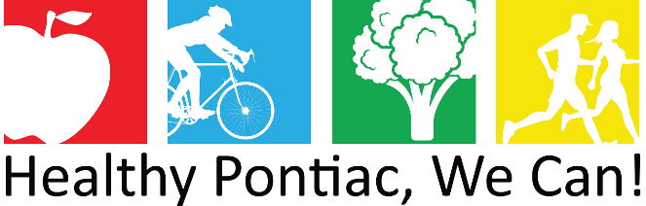
Meeting Agenda
Tuesday, June 8, 2021 ● 1:00 – 2:30 pm
Virtual

- Welcome
- Prescription for a Healthier Oakland, Rita Little & Elizabeth Onye
- Pontiac Community Survey Data Overview, Dr. Deidre Hurse
- Strategic Planning Conversation, Lisa Braddix, Elizabeth Crenshaw & Jessica Williams
- Partnership Updates

