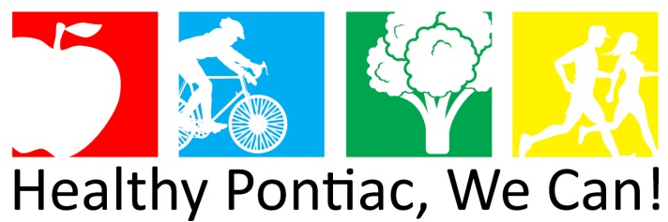

Agenda
Tuesday, June 5, 2018
1:00 – 3:00 PM
Resource & Crisis Center

- Welcome

- Introductions/Partnership Updates/Approval of Minutes

- Partner Speed Dater: Main Street Pontiac

- Networking Break

- Strategic Planning

HPWC! 2015-2018 healthy eating goal, objectives, & interventions

Healthy Eating Goal: | Increase consumption of fruits and vegetables through the implementation of policy, systems, environmental strategies that support healthy food environments.
Priority Objectives: | Increase access to alternative food outlets and sites offering nutrition education |  | Increase access to affordable healthy foods through home gardening, community gardening and emergency food programs | Develop a food policy committee to ensure local policies, ordinances, and environmental changes support healthy eating for residents of Pontiac
Interventions: | Continue partnerships with schools, grocery stores, and churches to provide alternative food outlets | Partner with Meet Up and Eat Up Program to support and promote summer feeding | Create availability of alternative gardening locations (community lots, schools, senior centers) | Collaborate with Oakland Schools, Private and Charter Schools to address school food policies

Next meeting date:
Tuesday, July 10, 2018
1:00 – 3:00 PM
Resource & Crisis Center (200 N. Telegraph Rd. 32E, Pontiac, MI 48341)

